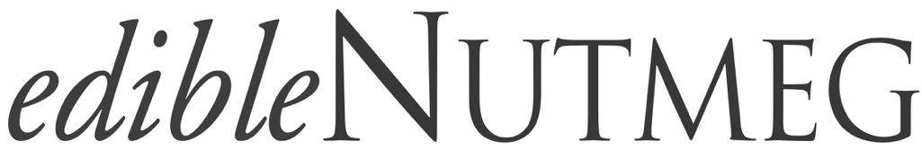

Subscription Form

Edible Nutmeg is a seasonal publication, dedicated to supporting and promoting the local food and farm community of western Connecticut. Whether it's current events, seasonal recipes, or stories on local food people, products, and establishments, Edible Nutmeg endeavors to bring the best of Connecticut's regional food community to the reader.
Subscribers provide the foundation for that mission and are crucial to its success, so thank you for your support! New issues are delivered directly to subscribers' doors, prior to their arrival in stores and newsstands.

Spring issue - arrives late March
Summer issue - arrives late June
Fall issue - arrives late September
Winter issue - arrives early December

A one year subscription is $28. Checks should be made out to Edible Nutmeg and mailed to:
Edible Nutmeg
P.O. Box 222
Washington Depot, CT 06794

Name
Address
City
ZIP
Email Address
Phone

